**Portfolio III: Knowledge Evidence Paper**

Kia Felder Williams

Dr. Joy Banks, Dr. Anya Evmenova, and Dr. Kelley Regan

George Mason University

January 15, 2024

**KNOWLEDGE EVIDENCE PAPER**

The Individuals with Disabilities Education Act (IDEA) mandates the collection of special education data enrollment for the 13 categories of disability, including Autism Spectrum Disorder (ASD). IDEA is federally regulated under the U.S. Department of Education (USDOE) umbrella. USDOE permits the 50 contiguous states and the District of Columbia sole discretion in determining student eligibility within the 13 categories of disability under IDEA. Eligibility determination for an ASD classification is determined by district-level personnel, implementing state-level parameters, and parent partnership (MacFarlane and Kanaya, 2009).

In 2021–22, the number of school-age students, ages 3–21, who received any combination of special education or related services under IDEA was 7.3 million (National Center for Educational Statistics (NCES), 2023). This is the equivalent of 15 percent of all students receiving a public-school education. Among the 7.3 million students receiving special education supports and services, ASD, the fourth largest and fastest growing category, encompasses 12 percent of the population.

**Figure 1**

*Percentage distribution of students ages 3–21 served under the Individuals with Disabilities Education Act, by selected disability type: School year 2021–22.*

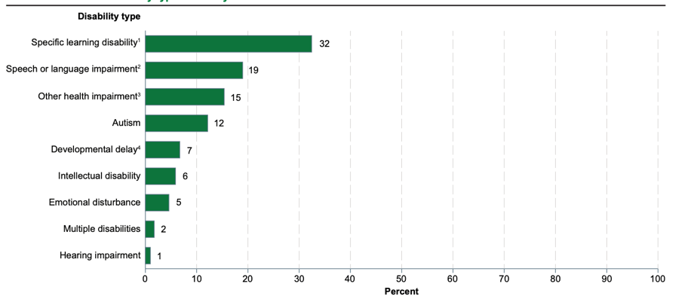

*Prevalence: Trends in Diagnoses*

Autism Spectrum Disorder (ASD) is a “neurodevelopmental disorder characterized by social interaction, verbal and nonverbal communication difficulties. Characteristics are generally evident before age three and adversely affects a child’s educational performance.” (IDEA, 300.8(c)(1); Pham and Charles, 2023). Children with Autism typically engage in stereotypy, rigidity to change of routine, and experience elevated sensitivities and unusual responses to sensory stimulus. Conversely, children with ASD demonstrate variations in their intelligence and memory, with strengths in visual pattern processing (Crespi, 2015; Hamilton et al., 2018).

According to the Centers for Disease Control and Prevention (CDC), ASD occurs in all racial, ethnic, and socioeconomic groups. In 2020, the CDC found that 1 in 36 eight-year-old children has ASD. This is a significant increase from the 2021 estimate of 1 in 44, which was an marked increase from 1 in 110 in 2006, and 1 in 150 in 2000 (Maenner et al., 2018; Maenner et al., 2020; Pham and Charles, 2023). These estimates are historically the highest ever recorded, and for the first time, the prevalence of ASD was lower among White children than among children of other races and ethnicities; thus, reversing the direction of past racial and ethnic differences in ASD prevalence.

Although ASD can be diagnosed in children as young as two years old (Filipek et al., 2000; Maenner et al., 2020), and studies have not indicated racial difference in incidence, distribution, and control of other factors relating to ASD (Fombonne, 2003; Yeargin-Allsopp et al., 2003), Black children are diagnosed with ASD at least a year and a half later than other White children (Mandell et al., 2009, 2002). Despite the findings that children with Medicaid have better access to services (Liptak et al., 2008), Black children were seen by mental health professionals for at least 8-months longer than White children before being receiving an ASD diagnosis (Mandell et al., 2002). Mandell et al (2007) states that Black children are more likely than White children to be misdiagnosed with disorders, such as attention deficit hyperactivity disorder, adjustment disorder, and conduct disorder, prior to receiving a correct diagnosis of ASD. Misdiagnosis has the potential to seriously impact a child’s cognitive and developmental trajectory given the positive implications of early intervention services. (Howlin et al., 2009; Virués-Ortega, 2010). The discrepancy in age of diagnosis between Black and White children indicates there is a need for a closer examination of the role of culture in phases preceding and during diagnoses of ASD in children.

**Figure 2**

*Reported autism spectrum disorder (ASD) prevalence by race or ethnicity, ADDM Network 2002-2020.*

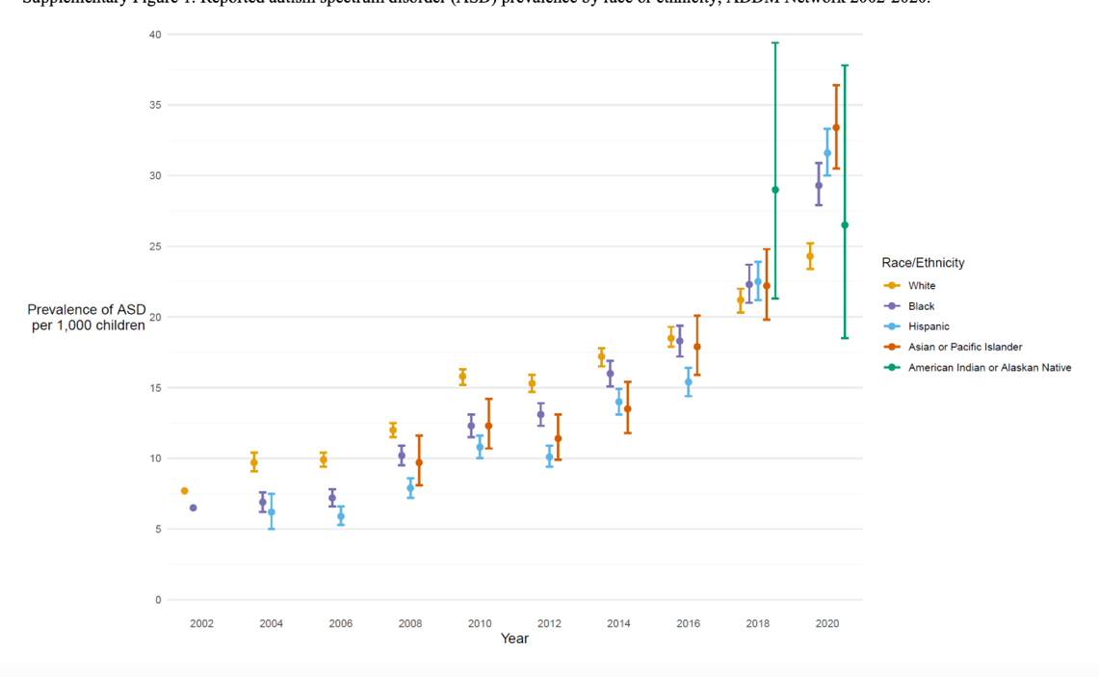

*Differential diagnoses of Black students*

The number of students aged 3-21, served under IDEA, as a percentage of total enrolment, varies by race and ethnicity. In the school year 2021-22, Black children had the second highest percentage of total enrollment at 17 percent. The prevalence of ASD has increased dramatically in the past 20 years, with current U.S. prevalence rates at 1:36 children (Maenner et al., 2020). Behavioral characteristics have been identified in children as young as 12-14 months of age (Zwaigenbaum et al., 2015), and ASD can be diagnosed with certainty by age 2 (Maenner et al., 2020; Charman et al., 2005, Lord et al., 2006). However, the average age of diagnosis is between 4-7 years of age (Baio et al., 2014), and can occur up to 3 years after parents share concerns about a perceived delay in reaching developmental milestones (McNally et al., 2020).

This delay is even more pronounced with children from lower income, ethnic/racial minority, and rural backgrounds. Although ASD is prevalent with strong biological and genetic markers, the reporting of symptoms, and willingness to seek support is impacted by sociocultural factors (Aylward et al., 2021; Pham and Charles, 2023; Ravindran and Myers, 2012). Culture is a set of behavioral norms, meanings, and values utilized by members of a particular society to construct their view of the world (Alarcón et al., 2009). The disparities in age of diagnosis for children of color with ASD are multifactorial and are affected by individual, family, and cultural-level factors. Poverty rates are typically higher in communities of color, and students in the United States and abroad conclude a positive socioeconomic status (SES) gradient in ASD prevalence, with prevalence increasing with higher SES indicators (Durkin et al., 2017).

Constantino et al (2020) found that the average age of diagnosis for Black children was over 5 years of age and commenced up to 3 years after parents first expressed concern about their child’s development. Constantino et al (2020) study is consistent with research that has found delay in diagnosis to be most occurring in children of color.

SES and race conflate where higher concentrations of Black and Latino families live in poorer neighborhoods (Drame, 2020). Studies have shown that White children and those of higher SES are more likely to be both identified and diagnosed with ASD earlier, compared with Black children and children from low-income families. Consequently, Black and lower-income children are less able to capitalize on early ASD intervention services during important developmental markers, when optimal neuroplasticity and synaptic proliferation occur (McNally et al., 2020).

Disparities in the age of diagnosis for Black children with ASD are impacted by sociodemographic influences and beliefs. The cause of ASD is not known. There is no medical test to determine whether an individual has ASD, so, absent increased education, cultural beliefs tend to shape how one thinks about the etiology of ASD and the trajectory of children who have Autism. Prior research showed that specific characteristics and traits manifest differently for children of varied age and gender. The age of diagnosis is later in girls than in boys, and girls exhibit fewer restrictive and repetitive behaviors than boys (Lai et al., 2015; Hiller et al., 2014; Van Wijngaarden-Cremers et al., 2014). SES and race are often conflated with higher concentrations of Back and Latino families living in poorer neighborhoods (Durkin et al., 2017). In their multi-state epidemiological study examining the interaction between SES and ASD identification from 2002-2010, they found that the children living in poorer neighborhoods whose parents had lower levels of post-graduate education, were less likely to be diagnosed with ASD, compared to those with higher education levels, living in more affluent communities. The disparity in diagnosis was associated with less access to healthcare professionals with the requisite skill and capacity to conduct the evaluation required for a proper Autism Spectrum Disorder diagnosis.

ASD is under-researched in multicultural populations (Dyches et al., 2004; El-Ghoroury & Krackow, 2012; Mandell & Novak, 2005), and even more limited in its study of ASD and Black families. Research of culturally based differences in perception is a critical genesis in determining whether Black caregivers have unique beliefs that impact a disparate diagnosis or impact recommendation for related services and interventions. An examination of ASD among Black children indicated critical disparities that may negatively influence treatment and outcomes for Black children with ASD (Filipek et al., 2020).

Although ASD can be diagnosed, with certainty, in children as young as 2 years old (Filipek et al., 2000) and studies have not indicated racial differences in the epidemiology of ASD (Fombonne, 2003; Yeargin-Allsopp et al., 2003), research has indicated that racial minorities are diagnosed with ASD later than their White counterparts (Mandell et al., 2009, 2002). Mandell and colleagues (2002) reported a disparity of a year-and-a-half delay in the diagnosis of autism in Black children compared to their White peers, among children with Medicaid; despite the finding that having Medicaid was associated with children with ASD having better access to some services (Liptak et al., 2008). Additionally, Black children were seen by mental health professionals for a significantly longer amount of time than White children (i.e., eight months) before being diagnosed with ASD (Mandell et al., 2002). Furthermore, it has been noted that Black children are less likely than White children to have access to quality health care and have a usual source of care (Weinick & Krauss, 2000), which limits the opportunity for continuity of care and makes appropriate screening procedures less likely to be effective (Mandell & Novak, 2005). Mandell (2007) reports that Black children are more likely to be misdiagnosed with disorders, such as attention deficit hyperactivity disorder, adjustment disorder, and conduct disorder prior to receiving a diagnosis of ASD, than other White children. This period of misdiagnosis can have a significant influence on a child’s developmental trajectory given the positive implications of intervention at an early age (Howlin et al., 2009; Virués-Ortega, 2010). The discrepancy in age of diagnosis between Black and White children indicates there is a need for a closer examination of the role of culture in the phases preceding and during diagnosis of ASD in children.

*Parent perception and causal/etiological beliefs*

There is little research examining causal beliefs and perceptions of Black caregivers. When controlling for SES, 58 percent of Black mothers' attribute ASD to vaccinations, whereas 37 percent of White parents ascribe to the same philosophy (Bazzano et al., 2012; Rivera-Figueroa, 2022). Beliefs that ASD is a mystery (Zuckerman et al., 2015) or a result of trauma (Dardennes et al., 2011) are associated with reduced behavioral intervention. Viewing ASD as a mystery can impact service consideration and use. A study of 305 mothers of children with ASD reported that those who described ASD as a mystery used more ASD intervention services, regardless of severity, race, ethnicity, or language (Reyes et al., 2018). Few studies have compared causal beliefs about ASD or how these beliefs impact service use across racial groups. Misconceptions likely contribute to reduced service use.

**Positionality Statement**

I am a wife, daughter, mother, teacher and student. I am a married Black woman, the youngest of three girls, and mother of four natural and two bonus children. I was born and raised in Montgomery County, Maryland, to racially and politically conscious parents, Rebecca and Isadore. When I was old enough to speak, my parents taught me that I was “*proud, educated, and Black* and I still recite that mantra…my children now recite this mantra. My parents were strong disciplinarians and reminded me daily, that “*I not only represent myself, but I represent the entire Felder family*”. I was trained to be an exemplar, to represent my race and my family well, and to “*show them better than I can tell them*”. Family, education, and representation were of paramount importance in my upbringing. Those ideals are at the core of who I am. As a public school special educator, administrator, and researcher, I practice being an A.C.E. – I *advocate* for those living on the margins, I *collaborate* with critical stakeholders, and I *educate* children with differing abilities.

My mother held post-graduate degrees in education and was a 30-year public school educator. My father was a semi-professional boxer, singer, and basketball player, and his one regret, as a result of being drafted to the Marines as a freshman in college, was that he never completed his college education. Until his passing, he adored his wife and three girls, Kim, Karyn, and Kia, the apples of his eye, and lived vicariously through our educational and professional attainments. My father, a handsome dark-skinned Marine, struggled with focus and comprehension in school, but excelled with anything that required the use of his hands, beautiful singing voice, and creativity. My father was one of those students who was marginalized because of the color of his skin, experienced low expectations at school and as a result sat in the back of the class, telling jokes and flirting with girls, to distract from his lack of comprehension and subsequent disinterest in the classroom. My desire to help Black children who learn differently traces back to my father’s struggles.

My grandfather drilled in my head that my sisters and I would have Dr. in front of our name -- just like he did. Dr. Silas E. Craft, Sr. was an educator and an administrator, and instrumental in integrating the public schools of Montgomery County, MD. He was a political giant who served as past president of the NAACP, and the first Black public school administrator in Montgomery County, Maryland. Watching my grandfather fight for equity in education, representation in administration and hearing the stories of his advocacy for Black families, instilled advocacy for marginalized communities, and a passion for equity in me.

My grandmother, Dorothye Beatrice McKnight Craft and her mother, *Nannye,* were pre-school and elementary educators when Black children learned in separate and unequal one-room schoolhouses. Though she taught for almost 40 years in one of the most affluent counties in the nation, I watched my mother, who lived from paycheck to paycheck, take from her modest earnings and provide dinner, school lunches, books, Christmas presents, socks, winter coats, and mittens for children and families who had less than we did. During the week and weekends, I watched my mother sit at the dinner table, and give extra care and attention to children who couldn’t read and couldn’t keep up in class, providing them with the skills and special instruction they needed. Often, my mother taught the child and parent. Like my mother, *I have a burden for education and families.*

I am a Christian and a minister. My axiology is rooted in my faith. I earned a Bachelor of Science in Management and Marketing with a concentration in Marketing, a Master of Arts in Biblical Studies with a concentration in Theology, a Master of Arts in Leadership in Teaching with an emphasis in Special Education, and teaching students with severe cognitive disabilities, postgraduate studies in Educational Leadership, and I am currently a doctoral student pursuing a Ph.D. in Special Education and secondary in Qualitative Research Methods. I taught students with Autism in self-contained and resource classrooms for nine years, served as a special education coordinator for eight of those years, mentor pre-service special educators and now serve as an Assistant Principal for a Title I school under Comprehensive School Improvement (CSI), earning that designation for consecutive underperformance of students with disabilities in instruction and assessment.

I am an administrator in the third largest, predominately African American school district in the Southeast. With more than 210 schools and over 140,000 students, I have personally witnessed thousands of Black families at the IEP table. Many of these families have children referred because a disability is suspected due to a lack of progress. Though the student population in Prince George’s County Public Schools (PGCPS) is over 80% Black (52%) and Latino of any race (39%), the special educators are not. While the student population continues to become more and more diverse, the special educator population continues to thin, become increasingly White, and monolingual. General and special educators are expected to understand, relate to, and instruct a culturally and linguistically diverse student population, without the appropriate tools, understanding, and sometimes the desire to do so. My lens and research questions emerge from this dichotomy. My research focus is how Black caregivers perceive the symptoms of ASD, and how such perceptions and experiences impact the recommendation of related services and academic intervention.

*Theoretical and Conceptual Framework*

The theoretical framework I will utilize is DisCrit (Annamma et al., 2013), focusing on tenets 3 and 4. Tenet 3 emphasizes the social constructions of race and ability and yet recognizes the material and psychological impacts of being labeled as raced or dis/abled, which sets one outside of the Western cultural norms, and tenet 4, privileges voices of marginalized populations, traditionally not acknowledged within research.

A researcher’s choice of framework is not arbitrary but reflects important personal beliefs and understandings about the nature of knowledge (Grant & Osanloo, 2014). Dis/ability Critical Race Theory will be employed by conducting qualitative research through narrative inquiry. Learning lived experiences and counterstories through family interviews of Black caregivers of children with Autism. The research questions that will guide my future study are, (1) How do Black parents of students with ASD perceive the symptoms of ASD that their children exhibit, (2) To what extent have Black parents been involved in the decision-making process of their child’s related services and academic interventions in special education, and (3) How have Black parents used the IEP meeting to monitor their child’s academic progress and growth in related services.

*Research Interest and Research Questions*

I am most interested in qualitative research and utilizing narrative inquiry to capture the lived experiences of Black families raising children with Autism. Narrative research highlights people’s lived experiences and can be used as a starting point for understanding how people make sense of their lives and for understanding how and why people’s stories are shaped and reshaped. The progression of this type of research that moves the narrative beyond simply telling the story to an understanding of the broader social and historical significance is compelling (Ravitch and Carl, 2021). For this study, my interview questions in *Table 1* center around the three research questions.

**Table 1**

*Interview Questions*

|  |  |
| --- | --- |
| **Research Question** | **Interview Questions** |
| How do Black parents of students with ASD perceive the symptoms of ASD that their children exhibit? | 1. Tell me about the definition of ASD 2. What was your knowledge of ASD prior to your child’s diagnosis? 3. Do you feel that the diagnosis is accurate? 4. Do you think Black students exhibit characteristics of ASD that are not part of the definition? |
| To what extent have parents been involved in the decision-making process of their child’s related services and academic interventions in special education? | 1. Tell me how you have been involved in the referral process? 2. Do you feel your child’s academic progress is monitored? 3. Tell me how the interventions were chosen for your child. |
| How have parents used the IEP meeting to monitor their child’s academic progress and growth in related services? | 1. How often do you attend IEP meetings? 2. Tell me about how you speak up for your child in the meetings? 3. What is your knowledge of the IEP meeting process? 4. How do you ensure that you feel equipped to share and ask questions in IEP meetings? 5. Tell me some of the ways your child’s progress is demonstrated to you in the IEP meeting. |

I am the primary source of both constructing and understanding my positionality, social identity, experiences, beliefs, prior knowledge, assumptions, ideologies, working epistemologies, biases, and overall perspective on the world (Ravitch and Carl, 2021).

**Dis/ability Critical Race Theory (DisCrit)**

Neglecting philosophical foundations in social research results in ontological assumptions that function as untheorized truths (Pascale, 2010). These assumptions are extremely powerful, because they shape what is considered valid knowledge, and they do so in ways that are not explicit, and therefore not accountable or open to doubt. A Dis/ability Critical Race (DisCrit) Theoretical framework is utilized to help one interpret and better understand Black experiences in racist, gendered, and ableist contexts (Drame et al., 2020), and challenges what constitutes as knowledge. DisCrit combines Critical Race Theory and Disability Studies (Annamma et al., 2013; Meekosha and Shuttleworth, 2009), and provides a theoretical foundation for analyses. In order to operationalize DisCrit in ways that would be most useful to scholars in both fields, Annamma et al (2013) drew on foundational intersectional and critical frameworks to develop a series of tenets (*Table 2)* that are perceived as integral to an intersectional approach to disability and race. As such, through seven tenets, DisCrit highlights a focus on race and ability and posits that those constructions uphold notions of normalcy, values and privileges multi-dimensional identities and marginalized voices traditionally devalued in traditional research, recognizes that gains made for persons with disabilities have largely been realized due to interest convergence with the White middle class, and demands activism and support for resistance.

**Table 2**

*The seven tenets of DisCrit*

|  |  |
| --- | --- |
| Tenet 1 | DisCrit focuses on ways that the forces of racism and ableism circulate  interdependently, often in neutralized and invisible ways, to uphold notions of normalcy. |
| Tenet 2 | DisCrit values multidimensional identities and troubles singular notions of identity such as race or dis/ability or class or gender or sexuality, and so on. |
| Tenet 3 | DisCrit emphasizes the social constructions of race and ability and yet recognizes the material and psychological impacts of being labeled as raced or dis/abled, which sets one outside of the western cultural norms. |
| Tenet 4 | DisCrit privileges voices of marginalized populations, traditionally not acknowledged within research. |
| Tenet 5 | DisCrit considers legal and historical aspects of dis/ability and race and how both have been used separately and together to deny the rights of some citizens. |
| Tenet 6 | DisCrit recognizes whiteness and ability as property and that gains for people labeled with dis/abilities have largely been made as the result of interest convergence of white, middle-class citizens. |
| Tenet 7 | DisCrit requires activism and supports in all forms of resistance. |

My research centers around tenets 3 and 4. DisCrit offers a foundation for exploring the relationship between race and ability and how being raced and disabled places Black children with disabilities at a pernicious nexus of marginalization (Annamma, 2013; Drame, 2020). As my research centers around Black caregivers raising children on the Autism spectrum, Black people are the foreground of discussions of theory. My research will explore how ability is racialized and race is disabled by structural, social, and systematic forces and constructs impact children who are both raced and disabled.

**Purpose and Significance**

Historically, several disability categories, including ASD, are based on clinical judgment regarding abilities that are intangible and not measurable. Specifically, in comprehensive school settings, IQ tests exist to operationalize and norm intelligence and skills, and are a primary determinant of “what supports and services children will receive, and parents must work within this system to gain the most helpful services...to protect their children from stigmatizing labels and practices that they believe may denigrate their [child’s] value in the eyes of society (p.7)”. (Harry and Ocasio-Stoutenburg, 2020). As intelligence and performance on assessments is a comprehensive reflection of prior opportunities to learn, differential performance of minority students on IQ and achievement tests is a product of educational disadvantage and the tragic history of limited cultural and educational opportunity (Skiba et al., 2001). The crux of this research sits at the intersection of race and ability and serves as an entry point for understanding how Black parents perceive the symptoms of ASD and how such experiences impact recommendations of the individualized educational program and subsequent academic growth of their child.

Utilizing a narrative inquiry and DisCrit lens, Black caregivers reified understanding of difference versus deficit and lived experiences of caregivers maneuvering the system that has historically disabled race and racialized ability (Annamma et al., 2013) will be captured. This research foci and purpose fills a critical knowledge gap, and it serves as an entry point for understanding how Black parents of children with ASD view characteristics of the disorder/disability and how such perceptions impact parents’ involvement in the selection of services and intervention.

**Gaps in the Literature**

Working with a team of doctoral students and advisors, I was heavily influenced by a research project that explored the experiences of BIPOC Children and Adults with ADHD: Prevalence, Perspectives, and Access. From that time until now, I have revisited the premise of that study and refined my focus. It remains my passion to research at the intersection of race and ability as an entry point of understanding how Black parents perceive the symptoms of ASD and how such experiences impact their recommendation of related services and academic interventions.

In a search for existing literature on perceptions of Black caregivers on ASD (*Appendix A2*), I conducted a preliminary review of the literature October 2023. The breadth of the research question asked, “*What is the perception of disability (SLD, OHI, ASD) in the African American community and how does perception impact access to care and treatment?*”. The focus of this research sits at the intersection of race and ability and serves as an entry point for understanding how African American parents experience the diagnostic process and how such experiences impact services. Due to the limited number of articles that included Black caregivers and ASD, the body of literature I reviewed was extended to include Specific Learning Disability (SLD) and Other Health Impairment (OHI). SLD was selected because it is the largest populated disability category under IDEA.

The term intersectionality is defined as the various ways in which race and gender interact to shape the multiple dimensions of Black experiences (Crenshaw, 1989). Intersectionality stresses how various social categories like race, gender, and class are not separate but exist in combination, and come together when facing challenges unique unto themselves.

**Methods**

A search strategy was used to conduct the literature review to guide the identification of relevant and peer-reviewed research articles focusing on the research topic and questions. Initially, keywords included “African American”, “Black” “African American community”, “Disability”, “Disability perception”, “Specific Learning Dis* (SLD)”, “health impairments”, “Autism spectrum disorder”, “ASD”, “access to care,” and “bias”. A search on EBSCO was conducted for peer-reviewed studies from 2018-2023. The PRISMA diagram (*Appendix A2)* outlines the inclusion and exclusion criteria applied for selection of sources.

Operational definitions were established for concepts introduced in the research question, including health care access/health care utilization, barriers to health care, facilitators to health care, underserved racial/ethnic groups, and disability (*Table 3*). Due to the exploratory nature of this review, broad definitions were utilized.

**Table 3**

*Operational Definitions for Keywords of the Review of Literature*

|  |  |  |
| --- | --- | --- |
| **Terms** | **Operational Definition** | **Search Terms** |
| Healthcare access | The availability or openness of health care | Healthcare services |
| Barriers to / Facilitators of healthcare access (services) | Any factor other than racial, ethnic, or disability status alone that impedes or enables health care access or utilization | Uninsured, health insurance |
| Underserved racial/ethnic group | Individuals from any racial or ethnic group that were traditionally or historically underserved or marginalized | Minority groups, racial and ethnic groups, Black, African American |
| Disability | Disability or functional limitations falling into at least one of the following categories: physical, sensory, cognitive, social, or activity limitation | Disabled persons, activities of daily living |

Using a systematic method, a review of the search results was conducted regarding the article's applicability to the question posed in the study. Special attention was paid to both qualitative and quantitative research to obtain a broad spectrum of views on disability perceptions and healthcare access among African Americans. Basic inclusion criteria were English-language, peer-reviewed journal publications from 2018-2023; about diagnoses for youth – age 25, of African ethnicity who also have a disability and reside in the United States. Included articles could describe observational or intervention research and were not limited by study design. The selected search method was designed to yield a broad current overview of the extant literature regarding the intersectionality of race, disability, and healthcare access among African Americans.

**Results**

In Pearson & Meadan (2018) seven themes emerged as they were related to experiences obtaining diagnoses: (a) navigation, (b) concerns initiated by others, (c) referrals, (d) extended family views, (e) parent knowledge of development and disability, (f) healthcare professional’s (HCP) knowledge of ASD, and (g) HCP response to parent concerns. Additionally, seven themes were categorized relating to accessing services: (a) advocacy, (b) partnerships with HCPs, service providers, and educators, (c) sources of support, (d) healthcare coverage and costs, (e) employment, (f) geographical location, and (g) family life events. Finally, three themes were identified in the caregiver’s recommendations for HCPs, service providers, educators, and parents. These themes include training, education, and experience. *Table 3* illustrates themes and sub-themes related to diagnoses, access to services, and recommendations for practice. These themes were further explored in Lovelace et al. (2018) using narrative inquiry to explore the unique challenges Black mothers face in accessing ASD services. *Table 4* captures a broad perspective of the myriad of facilitators and barriers in diagnoses and services that Black caregivers confront in accessing appropriate services for their children with ASD. ­­

**Table 4**

*Subthemes Related to Diagnoses, Access to Services, and Recommendations for Practice*

|  |  |  |  |
| --- | --- | --- | --- |
|  | **Facilitators** | **Barriers** | **Recommendations** |
| **Diagnosis** | * Parent knowledge of ASD * HCP knowledge of ASD * Higher SES * Community network | * Parent denial * HCP knowledge of ASD * Cultural differences between professionals and families | * Provide parent education * Increase community awareness * Increase HCP knowledge and training * Increase culturally responsive PD for educators * Build trust with families |
| **Services** | * Provide advocate liaison to help navigate * Increase access to community resources | * “Effective” advocacy * Healthcare/coverage costs * Work/time commitment * “Aggressive advocacy” * Lack of community resources | * Provide advocate liaison to help navigate * Increased access to community resources |

*Note: Pearson and Meadan (2018)*

*Caregiver Beliefs and Help-Seeking*

There is a network of cultural, social, and personal beliefs that influence the help–seeking behaviors of Black caregivers for individuals with a disability. Historical experiences like the Tuskegee Syphilis study have resulted in mistrust of the healthcare system, influencing the hesitancy for Black people to avoid seeking help from formal organizations (Scharff et al., 2015). A structure of skepticism regarding medical intervention forms the basis for the historical context pervading caregivers' attitudes. Benevides et al. (2018) highlighted the role that caregiver beliefs play in determining the measures to get childcare services for children with Autism. The results show that knowledge and expectations are essential stages of the help-seeking path, underscoring the complex interrelationship between caregivers' opinions and behaviors. Caregivers may subscribe to culturally specific ideas that serve as barriers to services and interventions, including a lack of motivation to seek services due to mistrust, fear, or (mis)understanding of Autism (Cadaret & Speight, 2018).

Tight-knit family and community structures influence decision-making, as caregivers may opt for informal family and community networks over formal services and interventions in the K-12 school setting. This implies that community-based support systems are crucial. Similarly, issues related to the perceived cultural competence of healthcare providers, financial barriers, and educational gaps about available services are also essential and affect the timing and nature of help-seeking behavior (Cadaret & Speight, 2018). In order to manage barriers, it is essential to implement culturally oriented medical practices, community support, and activities aimed at reducing stigmatization, raising awareness among members of the African American population, and building trust for assisting persons with disabilities in their respective communities.

*Parent-School Relationship*

The review of research on parent-school relationships and African American children with selected disabilities underscores the significance of collaboration between parents and schools. Brandon et al. (2021) utilized a Parent Reflection Questionnaire to offer feedback from African American parents of children with disabilities highlighting the importance of tailored strategies to involve parents and foster engagements between parents and schools. This theme is in line with Lovelace et al. (2018) qualitative study that reveals unique barriers to African American mothers of ASD children. The results show that culturally sensitive approaches in different domains of practice, including school-based services, are necessary for promoting positive parent-school relationships.

The synthesis suggests that parent-school relationships are critical in addressing barriers to care and treatment for African American children with disabilities. A conducive learning environment must be built around effective communication, mutual understanding and culturally responsive strategies. When interacting with schools, African American parents face challenges such as stigma, bias, and cultural differences. This calls for interventions aimed at improving parent-school collaboration and appreciating the cultural factors in African American communities. Educational institutions can help in removing these boundaries by giving attention to culturally- responsive practices leading to inclusive and equitable education for students with disabilities.

*Stigma: Black and disabled*

The stigma takes the shape of an insurmountable barrier toward the attainment of necessary care for African Americans with disabilities. The summation of different researchers, including Budhwani and De (2019) and Pearson et al. (2019), signifies that stigma in healthcare is a complex issue. Intersectionality involves a unique combination of hurdles to health care that result from the stigmas rooted in societal stereotypes and misconceptions. These studies shed light on how such stigma causes delays in diagnosis, restricted access to culturally adapted screening, and a reluctance to access services from health care systems.

Pearson et al. (2019) additionally argue that such a stigma goes beyond the people living with disabilities to touch impact the whole family. Specifically, African American parents, face obstacles based on racial bias and attitudes about disabilities perpetuated by American culture and the health care system. These various studies paint an unmistakable picture of how stigmatization functions as a systemic and interpersonal barrier, impeding every stage of the health-seeking pathway among African Americans with disabilities. The cumulative stigma, which has originated from the first moments of concern to the ongoing interactions with healthcare personnel, makes their surrounding environment both unforgiving and often actively inhibitive for them as a group. This synthesis of studies points out that stigma is a significant feature that affects the health outcomes for people of color, especially the Black communities. Implications include further research that can explore stigma and how this occurs, what causes it and the many forms it takes. Therefore, this involves studying stigma in healthcare settings, the role of cultural competence, and overcoming stigma (Rivera et al., 2021).

To improve caregiving efforts within the Black community, in relation to disabilities such as ASD, understanding the intricacies surrounding caregiver beliefs and their impact on help-seeking behavior in this community is required. Researchers need to understand cultural factors and their impact on decision-making regarding care-seeking from diagnostic and treatment facilities (Shaia et al., 2019). This would also provide a comprehensive insight into the barriers and facilitators to accessing care from the perspectives of both caregivers and healthcare professionals. Such methods would contribute to the introduction of targeted interventions.

Future studies might consider measures that can improve positive parent-school relationships in addressing inequality in access to treatment and education for African Americans with disabilities (Morgan, 2020). This entails designing efficient communication patterns, culturally sensitive approaches and bridging strategies for home and school. The research questions can be on parent-school relations' effect on educational outcomes, designing and evaluating culturally appropriate training programs for educators, and using technology-based platforms to facilitate communication between parents and schools. The findings from longitudinal studies involving students with disabilities can be used to develop policies and practices that promote inclusive and supportive learning environments in schools.

Using the current literature on disability diagnostic perception in black and brown communities, future research should aim at understanding the diagnosis and treatment disparities. Investigation of systems factors, culturally competent diagnostic processes, and developing interventions to overcome the barriers outlined in the literature. Such research questions include the impact of cultural tailoring in diagnostic processes, the efficacy of community-based outreach initiatives, and the perspectives of individuals with disabilities and their families regarding the diagnostic process (Bigby & Beadle-Brown, 2018).

Future research will also have broad implications for policymakers and those who are advocating in this field. The findings from research should guide the development of culturally sensitive policies aimed at addressing the inequitable provision of care and treatment among Blacks with disabilities (Handtke et al., 2019). This can include pushing for enhanced participation by people from different communities in policy frameworks concerning health, education, and disability issues. In addition, future research should investigate how individuals with disabilities and their families can participate in creating policies that govern their lives. Research outcomes should be aligned with advocacy initiatives, thereby increasing the chances of systemic change in favor of the value system that prioritizes inclusiveness, equity, and availability of care and treatment in African American communities with disabilities (Handtke et al., 2019).

From this literature review, I learned that my focus for the study was entirely too broad. The purpose has been narrowed down to aid in specific research concerning Black caregiver perception of ASD diagnosis and their recommendation for related services and interventions.

The review identified 134 unique references (Appendix A2). Many abstracts were excluded because they did not include the target age group, ethnicity, or were non-US studies. Inclusion criteria identified 15 articles exploring barriers to services.

**Future Research Design and Methods**

Despite the extensive research on childhood ASD, there is still much to learn about the association between the perceptions and meanings parents ascribe to an ASD diagnosis and their acquisition of care and treatment for their child. This study will examine Black caregivers’ perceptions of ASD symptoms and how that informs parent recommendations of service and intervention.

Semi-structured interviews and observations of parents of children aged 5 to 11 recently diagnosed with ASD will serve as a basis for understanding of their child’s behaviors and their service expectations. Through narrative inquiry, data will be collected to describe how parents interpret the definition of ASD, determine the accuracy of the diagnosis, and characterize the symptoms that their children with ASD exhibit. Additional interview questions will explore parents' decisions and recommendations for interventions.

The purpose of this study is to describe and analyze the experiences and perceptions of Black caregivers of children identified with ASD, and the impact those perceptions have on related services and intervention implementation. Disability critical race theory will be utilized as a framework to examine the responses of the participants. Moreover, tenets 3 and 4 of DisCrit will guide the development of the research and interview questions. Qualitative data will be gathered via interviews, to bring to light Black caregivers’ experiences and their counter stories (Solórzano & Yosso, 2002) of the special education system servicing their children. The research questions guiding this study are found in *Table 1.*

*Data Collection*

To explore the experiences of Black parents of children with ASD, participants will complete a family background questionnaire and take part in semi-structured interviews. A questionnaire like The Family Information Questionnaire will be used to collect demographic information about the parents and the types of services their children with ASD may already receive. The questionnaire will take 5–10 minutes to complete and include demographic questions such as caregivers age, gender, marital status, level of education, employment status, family income, and child(ren) information.

*Data Analysis*

Data from the questionnaire will be analyzed to provide descriptive information about the participants. The questionnaire will be compared to the interview data to provide triangulation regarding the type and frequency of services.

*Credibility and Trustworthiness*

To select appropriate respondents, participants will be recruited from schools across PGCPS. Participants will be screened prior to scheduling the interview to verify they meet research study criteria. A snowball sampling technique will be employed, and each participant will be given a flyer or QR code to share with other families in their circles of influence and community. These measures will be used to ensure that the sample is purposely identified, effectively recruited, adequate in number, and representative (Creswell and Creswell 2023).

To ensure that the data are credible and trustworthy I will employ data triangulation of the questionnaire and interviews. As well as reflexivity, being forthright about my positionality and perspectives with this research's context, monitoring biases through memos and field notes. Member checks will also be used to confirm the accuracy of transcription and to build trust and support of conclusions.

**Appendix A**

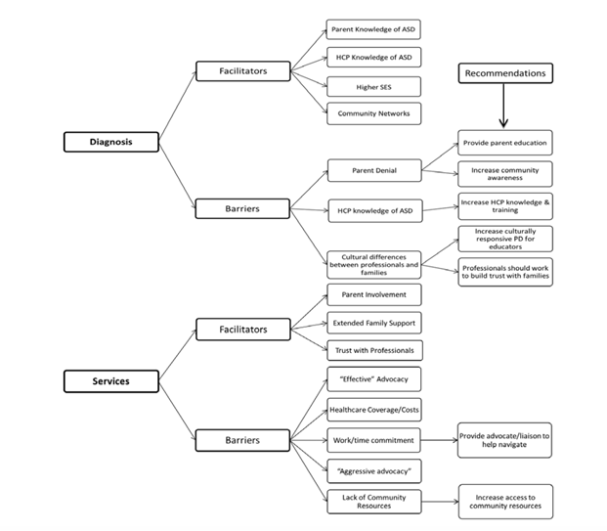

Figure A1. Facilitators and Barriers to Diagnosis and Services

**PRISMA table for prior review of literature.**

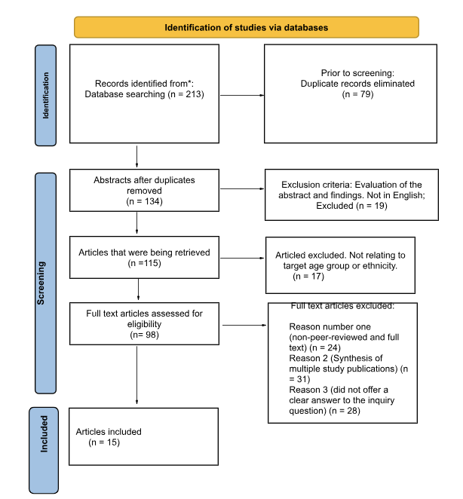**Figure A2. PRISMA table.**

**References**

Annamma, S. A., Connor, D., & Ferri, B. (2013). Dis/ability critical race studies (DisCrit): Theorizing at the intersections of race and dis/ability. *Race ethnicity and education*, *16*(1), 1-31. <https://doi.org/10.1080/13613324.2012.730511>

Aylward, B. S., Gal-Szabo, D. E., & Taraman, S. (2021). Racial, ethnic, and sociodemographic disparities in diagnosis of children with autism spectrum disorder. *Journal of Developmental and Behavioral Pediatrics*, *42*(8), 682. <https://doi.org/10.1097/DBP.0000000000000996>

Bazzano, A., Zeldin, A., Schuster, E., Barrett, C., & Lehrer, D. (2012). Vaccine-related beliefs

and practices of parents of children with autism spectrum disorders. *American Journal*  *on Intellectual and Developmental Disabilities*, *117*(3), 233-242.

Benevides, T., DeGrace, B., & Kearney, P. (2018). African American Caregivers’ Perceptions of Care Needs Affecting Access to Services for Their Children With Autism. *American Journal of Occupational Therapy*, *72*(4_Supplement_1), 7211510213p1. <https://doi.org/10.5014/ajot.2018.72s1-rp301c>

Bigby, C., & Beadle-Brown, J. (2018). Improving Quality of Life Outcomes in Supported Accommodation for People with Intellectual Disability: What Makes a Difference? *Journal of Applied Research in Intellectual Disabilities*, *31*(2), e182–e200. <https://doi.org/10.1111/jar.12291>

Brandon, R. R., Higgins, K., Jones, V. L., & Dobbins, N. (2021). African American Parents With Children With Disabilities: Gathering Home–School Reflections. *Intervention in School and Clinic*, 105345122110018. <https://doi.org/10.1177/10534512211001837>

Budhwani, H., & De, P. (2019). Perceived Stigma in Health Care Settings and the Physical and Mental Health of People of Color in the United States. *Health Equity*, *3*(1), 73–80. <https://doi.org/10.1089/heq.2018.0079>

Cadaret, M. C., & Speight, S. L. (2018). An Exploratory Study of Attitudes Toward Psychological Help Seeking Among African American Men. *Journal of Black Psychology*, *44*(4), 347–370. <https://doi.org/10.1177/0095798418774655>

Constantino, J. N., Abbacchi, A. M., Saulnier, C., Klaiman, C., Mandell, D. S., Zhang, Y., Hawks, Z., Bates, J., Klin, A., Shattuck, P., Molholm, S., Fitzgerald, R., Roux, A., Lowe, J. K., & Geschwind, D. H. (2020). Timing of the Diagnosis of Autism in African American Children. *Pediatrics*, *146*(3), e20193629. <https://doi.org/10.1542/peds.2019-3629>.

Cadaret, M. C., & Speight, S. L. (2018). An exploratory study of attitudes toward psychological help seeking among African American men. *Journal of Black Psychology*, *44*(4), 347-370. http://doi.org/10.1177/0095798418774655.

Carter, S. M., & Little, M. (2007). Justifying knowledge, justifying method, taking action:

Epistemologies, methodologies, and methods in qualitative research. *Qualitative health*

*research*, *17*(10), 1316-1328.

Cho, J., & Trent, A. (2006). Validity in qualitative research revisited. *Qualitative*

*Research, 6*(3), 319-340.

Craft, E., & Howley, A. (2018). African American Students’ Experiences in Special Education

Programs. *Teachers College Record: The Voice of Scholarship in Education*, *120*(10), 1–

35. <https://doi.org/10.1177/016146811812001001>

Crenshaw, K. W. (1995). Mapping the margins: Intersectionality, identity politics, and violence

against women of color. In K. W. Crenshaw, N. Gotanda, G. Peller, & K. Thomas

(Eds.), CRT: The key writings that formed the movement (pp. 357-383). New York, NY: The New Press.

Dardennes, R. M., Al Anbar, N. N., Prado-Netto, A., Kaye, K., Contejean, Y., & Al Anbar, N.

N. (2011). Treating the cause of illness rather than the symptoms: Parental causal beliefs

and treatment choices in autism spectrum disorder. *Research in developmental*

*disabilities*, *32*(3), 1137-1146. [http://doi.org/10.1016/j.ridd.2011.01.010](http://www.doi.org/10.1016/j.ridd.2011.01.010)

Dyches, T. T., Wilder, L. K., Sudweeks, R. R., Obiakor, F. E., & Algozzine, B. (2004).

Multicultural issues in autism. *Journal of autism and developmental disorders*, 34, 211-

222.

El-Ghoroury, N. H., & Krackow, E. (2012). Enhancing the identification of autism spectrum disorders via a model of culturally sensitive childhood assessment. *Professional Psychology: Research and Practice, 43*(3), 249. <https://doi.org/10.1037/a0027354>

Fombonne, E. (2003). Epidemiological surveys of autism and other pervasive developmental disorders: an update. *Journal of autism and developmental disorders*, *33*, 365-382.

Grant, C., & Osanloo, A. (2014). Understanding, selecting, and integrating a theoretical framework in dissertation research: Creating the blueprint for your “house”. *Administrative issues journal*, *4*(2), 4.

Handtke, O., Schilgen, B., & Mösko, M. (2019). Culturally competent healthcare – A scoping review of strategies implemented in healthcare organizations and a model of culturally competent healthcare provision. *PLOS ONE*, *14*(7), 1–24. <https://doi.org/10.1371/journal.pone.0219971>

Harris, Cheryl I., Whiteness as Property. Harvard Law Review, Vol. 106, No. 8, p. 1707, 1993, UCLA School of Law Research Paper No. 06-35, Available at SSRN: <https://ssrn.com/abstract=927850>

Harry, B., & Ocasio-Stoutenburg, L. (2020). *Meeting families where they are: Building equity through advocacy with diverse schools and communities*. Disability, Culture, and Equity Series.

Howlin, P., Goode, S., Hutton, J., & Rutter, M. (2009). Savant skills in autism: psychometric approaches and parental reports. Philosophical Transactions of the Royal Society B: *Biological Sciences, 364*(1522), 1359-1367. <https://doi.org/10.1098/rstb.2008.0328>

Kogan, M. D., Vladutiu, C. J., Schieve, L. A., Ghandour, R. M., Blumberg, S. J., Zablotsky, B.,

Perrin, J. M., Shattuck, P., Kuhlthau, K. A., Harwood, R. L., & Lu, M. C. (2018). The

Prevalence of Parent-Reported Autism Spectrum Disorder Among US Children.

*Pediatrics*, *142*(6), e20174161. <https://doi.org/10.1542/peds.2017-4161>

Ladson-Billings, G. (2000). Racialized discourses and ethnic epistemologies. In N. K. Denzin & Y. S. Lincoln (Eds.), Handbook of qualitative research (2nd ed., pp. 257-277).

Thousand Oaks, CA: SAGE.

Ladson-Billings, G., & Tate, W. F. (1995). Toward a critical race theory of education. *Teachers*

*College Record*, *97*(1), 47-68.

Liptak, G. S., Benzoni, L. B., Mruzek, D. W., Nolan, K. W., Thingvoll, M. A., Wade, C. M., &

Fryer, G. E. (2008). Disparities in diagnosis and access to health services for children

with autism: data from the National Survey of Children's Health. *Journal of*

*Developmental & Behavioral Pediatrics*, *29*(3), 152-160.

Lovelace, T. S., Robertson, R. E., & Tamayo, S. (2018). Experiences of African American Mothers of Sons with Autism Spectrum Disorder: Lessons for Improving Service Delivery. *Education and Training in Autism and Developmental Disabilities*, *53*(1), 3–16. <https://www.jstor.org/stable/26420423>

MacFarlane, J. R., & Kanaya, T. (2009). What does it mean to be autistic? Inter-state variation in special education criteria for autism services. *Journal of Child and Family Studies,18*(6), 662.

Maenner MJ, Warren Z, Williams AR, et al. (2020). Prevalence and Characteristics of Autism Spectrum Disorder Among Children Aged 8 Years — Autism and Developmental Disabilities Monitoring Network, 11 Sites, United States, 2020. MMWR Surveill Summ 2023;72(No. SS-2):1–14. <http://doi.org/10.15585/mmwr.ss7202a1>.

Mandell, D. S., Novak, M. M., & Zubritsky, C. D. (2005). Factors associated with age of diagnosis among children with autism spectrum disorders. *Pediatrics*, *116*(6), 1480-1486. <http://doi.org/10.1542/peds.2005-0185>

Meekosha, H., & Shuttleworth, R. (2009). What's so ‘critical’about critical disability studies?

*Australian journal of human rights, 15*(1), 47-75

Morgan, H. (2020). Misunderstood and mistreated: Students of color in special

education. *Online Submission*, *3*(2), 71-81. <http://dx.doi.org/10.32623.3.10005>

National Center for Education Statistics. (2023). Students With Disabilities. *Condition of*

*Education*. U.S. Department of Education, Institute of Education Sciences. Retrieved

January 8, 2024, from [https://nces.ed.gov/programs/coe/indicator/cgg](https://nces.ed.gov/programs/coe/indicator/cgg/students-with-disabilities).

Nind, M., Wiles, R., Bengry-Howell, A., & Crow, G. (2013). Methodological innovation and

research ethics: forces in tension or forces in harmony? *Qualitative Research*, *13*(6),

650-667.

O’Donnell, P., Tierney, E., O’Carroll, A., Nurse, D., & MacFarlane, A. (2016). Exploring levers and barriers to accessing primary care for marginalized groups and identifying their priorities for primary care provision: a participatory learning and action research study. International journal for equity in health, 15, 1-16.

Pearson, J. N., & Meadan, H. (2018). African American parents' perceptions of diagnosis and services for children with Autism. *Education and Training in Autism and Developmental Disabilities*, *53*(1), 17-32. <https://files.eric.ed.gov/fulltext/EJ1179135.pdf>

Pearson, J. N., Meadan, H., Malone, K. M., & Martin, B. M. (2019). Parent and Professional Experiences Supporting African American Children with Autism. *Journal of Racial and Ethnic Health Disparities*. <https://doi.org/10.1007/s40615-019-00659-9>

Rivera-Figueroa, K., Marfo, N. Y. A., & Eigsti, I. M. (2022). Parental perceptions of autism spectrum disorder in Latinx and Black sociocultural contexts: A systematic review. *American journal on intellectual and developmental disabilities*, *127*(1), 42-63. [http://doi.org/10.1352/1944-7558-127.1.42](http://www.doi.org/10.1352/1944-7558-127.1.42)

Rivera, K. J., Zhang, J. Y., Mohr, D. C., Wescott, A. B., & Pederson, A. B. (2021). A Narrative

Review of Mental Illness Stigma Reduction Interventions Among African Americans in

The United States. *Journal of mental health & clinical psychology*, *5*(2), 20–31. <https://doi.org/10.29245/2578-2959/2021/2.1235>

Reybold, L. E., Matson, K, & Daley, H. (2018). Reclaiming triangulation in qualitative

research: From sailors and surveyors to social scientists. Paper presented to the 2018

annual American Educational Research Association (AERA). NY, New York.

Pascale, C. M. (2010). *Cartographies of knowledge: Exploring qualitative epistemologies*. Sage

Publications.

Ravitch, S. M., & Carl, N. M. (2019). *Qualitative research: Bridging the conceptual, theoretical,*

*and methodological*. Sage Publications.

Saldana, J. (2014). *Thinking qualitatively: Methods of mind*. SAGE publications.

Scharff, D. P., Mathews, K. J., Jackson, P., Hoffsuemmer, J., Martin, E., & Edwards, D. (2010).

More than Tuskegee: understanding mistrust about research participation. Journal of

health care for the poor and underserved, 21(3), 879. <https://doi.org/10.1353/hpu.0.0323>

Shaia, W. E., Nichols, H. M., Dababnah, S., Campion, K., & Garbarino, N. (2019). Brief Report: Participation of Black and African American Families in Autism Research. *Journal of Autism and Developmental Disorders*, *50*(5), 1841–1846. <https://doi.org/10.1007/s10803-019-03926-0>

Vaught, S. E. (2011). Racism, public schooling and the entrenchment of white supremacy: A

critical race ethnography. Albany: State University of New York Press.

Villenas, S., & Deyhle, D. (1999). Critical race theory and ethnographies challenging the

stereotypes: Latino families, schooling, resilience and resistance. Curriculum inquiry,

29(4), 413-445.

Virués-Ortega, J. (2010). Applied behavior analytic intervention for autism in early childhood:

Meta-analysis, meta-regression and dose–response meta-analysis of multiple

outcomes. *Clinical psychology review*, *30*(4), 387-399.

Weinick, R. M., & Krauss, N. A. (2000). Racial/ethnic differences in children's access to

care. *American Journal of Public Health*, *90*(11), 1771.

Yeargin-Allsopp, M., Rice, C., Karapurkar, T., Doernberg, N., Boyle, C., & Murphy, C. (2003).

Prevalence of autism in a US metropolitan area. *Jama*, *289*(1), 49-55.

[http://doi.org/10.1001/jama.289.1.4](http://www.doi.org/10.1001/jama.289.1.4)

Zuckerman KE, Sinche B, Cobian M, Cervantes M, Mejia A, Becker T, & Nicolaidis C

(2014). Conceptualization of autism in the Latino community and its relationship with

early diagnosis. *Journal of Developmental and Behavioral Pediatrics*, 35(8), 522–532.

[http://doi.org/10.1097/DBP.0000000000000091](http://www.doi.org/10.1097/DBP.0000000000000091)